Name __________________________________________ Date ________________________
Science Ms. Hanna

What is the volume of the liquid shown in graduated cylinders 1-4 below? What is the total volume of liquid in graduated cylinder 5? What is the volume of the rock (use graduated cylinder 4 and then 5)?

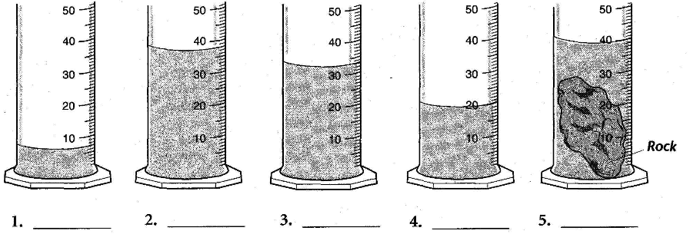6. Volume of Rock? ________________

Find the volume of the steel cylinder and the ring.
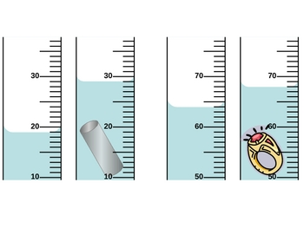
Volume of cylinder ______________ Volume of ring ______________

What is the volume of the rock?
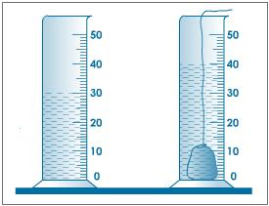

Volume of rock= _______________________________

