Name ___________________________________________________ Date _____________________
Science Ms. Hanna

SpongeBob and his Bikini Bottom pals have been busy doing a little research. Read the description for each experiment and answer the questions.
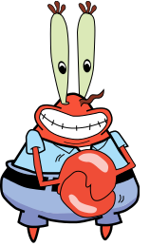
1 - Patty Power
Mr. Krabbs wants to make Bikini Bottoms a nicer place to live. He has created a new sauce that he thinks will reduce the production of body gas associated with eating crabby patties from the Krusty Krab. He recruits 100 customers with a history of gas problems. He has 50 of them (Group A) eat crabby patties with the new sauce. The other 50 (Group B) eat crabby patties with sauce that looks just like new sauce but is really just mixture of mayonnaise and food coloring. Both groups were told that they were getting the sauce that would reduce gas production. Two hours after eating the crabby patties, 30 customers in group A reported having = fewer gas problems and 8 customers in group B reported having fewer gas problems.

Which people are in the control group?

What is the independent variable?

What is the dependent variable?

What should Mr. Krabs’ conclusion be?

Why do you think 8 people in group B reported feeling better?

2 – Slimotosis
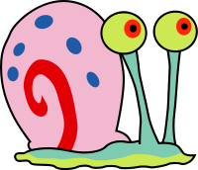
Sponge Bob notices that his pal Gary is suffering from slimotosis, which occurs when the shell develops a nasty slime and gives off a horrible odor. His friend Patrick tells him that rubbing seaweed on the shell is the perfect cure, while Sandy says that drinking Dr. Kelp will be a better cure. Sponge Bob decides to test this cure by rubbing Gary with seaweed for 1 week and having him drink Dr. Kelp. After a week of treatment, the slime is gone and Gary’s shell smells better.

What is the problem being investigated?

What is the independent variable?

What is the dependent variable?

What should Sponge Bob’s conclusion be? (Which "cure" worked the best?)

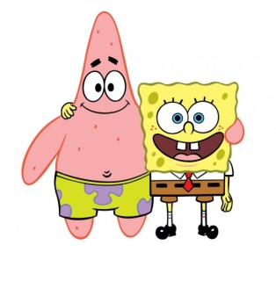
3 – Marshmallow Muscles
Larry was told that a certain muscle cream was the newest best thing on the market and claims to double a person’s muscle power when used as part of a muscle-building workout. Interested in this product, he buys the special muscle cream and recruits Patrick and SpongeBob to help him with an experiment. Larry develops a special marshmallow weight-lifting program for Patrick and SpongeBob. He meets with them once every day for a period of 2 weeks and keeps track of their results. Before each session Patrick’s arms and back are lathered in the muscle cream, while Sponge Bob’s arms and back are lathered with the regular lotion.

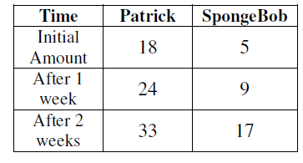
Which person is in the control group?

What is the independent variable?

What is the dependent variable?

What should Larry’s conclusion be?

