Name __________________________
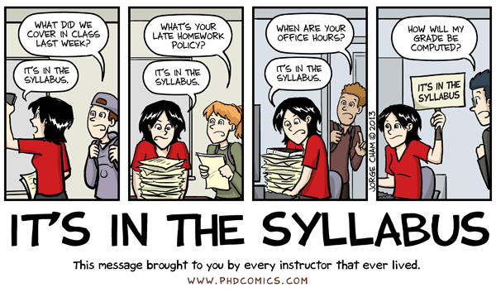
Ms. Hanna

Syllabus
Scavenger
Hunt

Your syllabus is loaded with helpful information about this class. Let’s see what you can find! (The questions are NOT in order…that would be too easy. This is designed to help ensure that you actually read your syllabus!)

- How do I contact Ms. Hanna outside of class?

- How will projects count towards my grade?

- Where should I record my assigned work (where do I write my HW down)?

- How many dividers do I need?

- How do I label them?

- How much does HW count toward my grade?

- How many units will we cover this year?

- Is this class mostly about physical or life science?

- What is it called when you smell a substance, but you don’t inhale or taste it?

- What is 1 piece of safety equipment I should be able to find in the classroom?

- What is 1 way that I can work towards success in this class?

- What materials do I need for class EVERY DAY?

- When is HW due?

- How do I find out my grade, on my own?

- What do I do about missed work if I am out or have a lesson?

- When is my work due if I am absent?

