Name_______________________________________ Date _________________

Science Ms. Hanna

[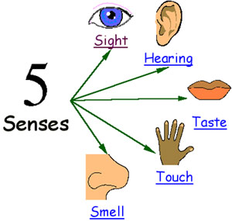](http://www.google.com/url?sa=i&rct=j&q=&esrc=s&frm=1&source=images&cd=&cad=rja&docid=_d6jkJ8CG8nbhM&tbnid=dQX7yF0ZMifg8M:&ved=0CAUQjRw&url=http://www.comicvine.com/profile/rbysjti/blog/which-among-the-5-senses-would-you-prefer-to-lose/50411/&ei=F-zIUZfINMaFrQeb-4DoDQ&psig=AFQjCNGR5LaVqPph9EI8FViTFzVpl5ShSQ&ust=1372208262981107)

**Part 1: Scientific Skills Vocab**

***What are your 5 senses??***

5 Senses

**Observation:** To use your ______________________________________ to gather information

**Inference:** To give a possible ________________________________ for an observation

[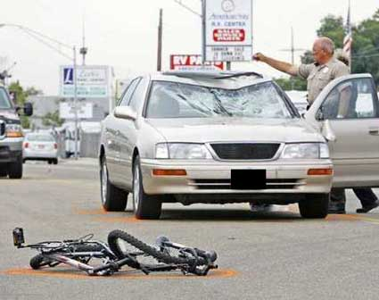](http://www.google.com/url?sa=i&rct=j&q=&esrc=s&frm=1&source=images&cd=&cad=rja&docid=Umgld4JhDif6WM&tbnid=-7Kay3c0jyuYZM:&ved=0CAUQjRw&url=http://blog.leizerman.com/2013/03/avoid-bike-car-collisions-with-these-helpful-riding-reminders/&ei=fuLIUdKAC4jSrQextIDADg&psig=AFQjCNF0gPnkfi6Ce1dagHoLWy6go5AURA&ust=1372205933537197)Ex.

Observation:

Inference:

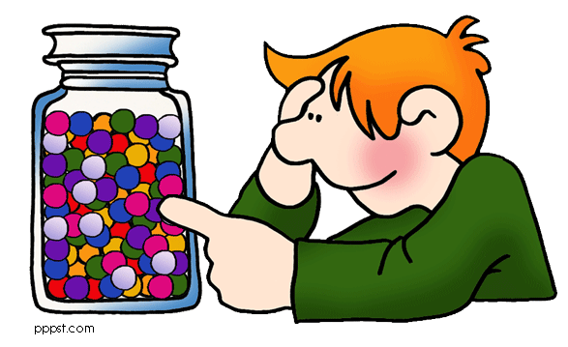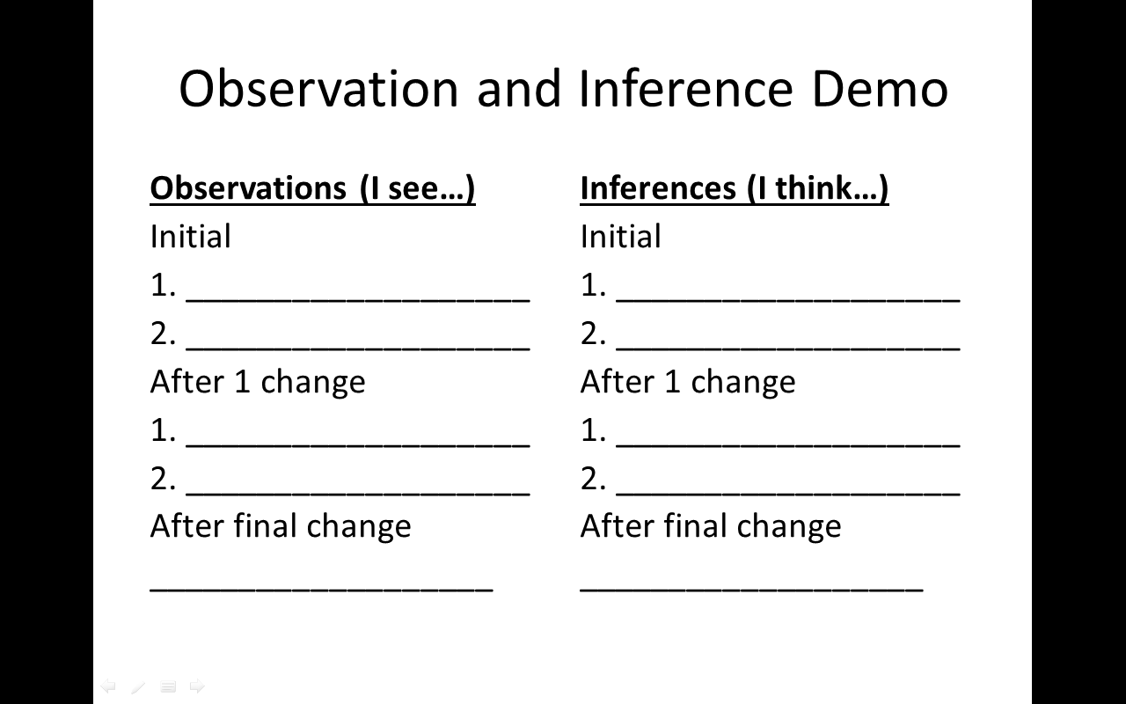

**Estimate:** to make a careful ________________________________

Ex. How many pieces of candy (M&Ms) are in the container? _____________

**Measure:** To find the ______________________________ amount of something

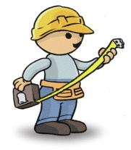Ex. Measure the object on your desk in cm. Record your measurement for length and width below

length: ________________________ width : _________________________

[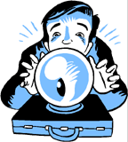](http://www.google.com/url?sa=i&rct=j&q=&esrc=s&frm=1&source=images&cd=&docid=lVw-_h9AB8GyIM&tbnid=L-ghFjrMvq2LnM:&ved=0CAUQjRw&url=http://blog.kensington.com/security/2011/02/01/security-predictions-for-2011-and-onward-part-3/&ei=Zl_LUYXuCYbZ0QH41IBo&bvm=bv.48340889,d.dmg&psig=AFQjCNEL2XFQ1LZ6fQWAOEE8qtVvmHX4OQ&ust=1372369069033013)**Predict:** To guess about the _________________________ based on the past.

Ex. Predict what the weather will be like in two days

Temperature: __________________________ Climate (rain/cloudy/sunny):_____________________________

**Classify:** To _______________________________ items based on how they are alike

Ex. Classify the group of animals in front of you in the bag. Write down below how or what characteristic you use to classify the animals.

Group A: ______________________________________________________________________________________

Group B: _______________________________________________________________________________________

Group C: _______________________________________________________________________________________

**Hypothesize:** To suggest an ___________________________________ to a problem

Ex. What student do you think will have the middle most height in your class?

I believe that ___________________________ will have the middle most height

Was your hypothesis support or denied? ___________________________

**Record and organize:** To take down _____________________________ (data) and arrange them into a __________________________ or a ____________________________

**Conclusions:** To give ________________________________ result to a problem.

Ex.

[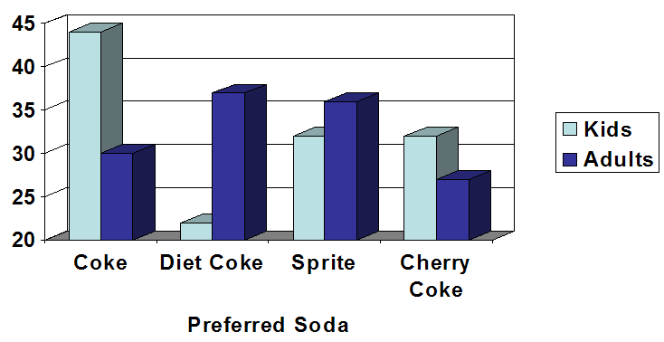](http://www.google.com/url?sa=i&rct=j&q=&esrc=s&frm=1&source=images&cd=&cad=rja&docid=JjqtmK_Kh9qisM&tbnid=1aGoM6VdhLNdfM:&ved=0CAUQjRw&url=http://onlinestatbook.com/chapter2/ch2_exercises.html&ei=QwHJUeWHL4nJrAeB54GYAw&v6u=https://s-v6exp1-v4.metric.gstatic.com/gen_204?ip=70.215.10.140&ts=1372127514890729&auth=oqcsuc6lbbeeypcltq5dddgp6zacf5ta&rndm=0.4966619587525181&v6s=2&v6t=40351&psig=AFQjCNGCEtaqD71LQT_tHIezpiji1hsK9A&ust=1372213914912946)

What is the preferred soda for kids? ______________________

What is the preferred soda for Adults? ______________________

So if you were throwing a party for a bunch of families, what beverages would you buy and why?

**Part 2: Measurement Skills**

**Converting through the metric system**. Use the following chart to convert the measurements.

______ ______ ______ ______ ______ ______ ______

KILO 🡪 HECTO 🡪 DECA 🡪 (UNITS) 🡪 DECI 🡪 CENTI 🡪 MILLI

55 mm = __________________ cm

1.3 m = ___________________cm

15 m = ___________________ km

4.02 cm = ___________________mm

76.23 km = _________________________m

0.3 cm = ________________________m

**Measuring length with a Metric Ruler**

[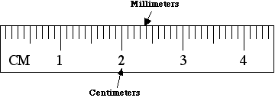](http://www.google.com/url?sa=i&rct=j&q=&esrc=s&frm=1&source=images&cd=&cad=rja&docid=Gk3JTbv9JO5NEM&tbnid=EBzB2NOAgouBzM:&ved=&url=http://69.167.181.201/~lakeview/science/metric/length.htm&ei=t6TLUZqjA477rAeH14DoCA&bvm=bv.48340889,d.bmk&psig=AFQjCNG3N_gDIn2JorM9orf-E0IL8LkmdA&ust=1372386871465063)When measuring with a metric ruler all answers must be in decimal form and must include the centimeters followed by a decimal then the millimeters.

[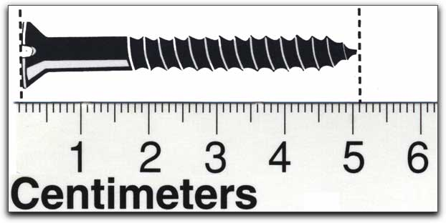](http://www.google.com/url?sa=i&rct=j&q=&esrc=s&frm=1&source=images&cd=&cad=rja&docid=qwprENtQoCO6aM&tbnid=4LU6qrXVModcTM:&ved=0CAUQjRw&url=http://mail.colonial.net/~hkaiter/metric_system_measurement.html&ei=xqPLUYGLK4WIrAfTqIHACQ&bvm=bv.48340889,d.bmk&psig=AFQjCNFyktXxyXb-Tthz9g63MrovbwYm3Q&ust=1372386591668445)

What is the measurement of the screw?

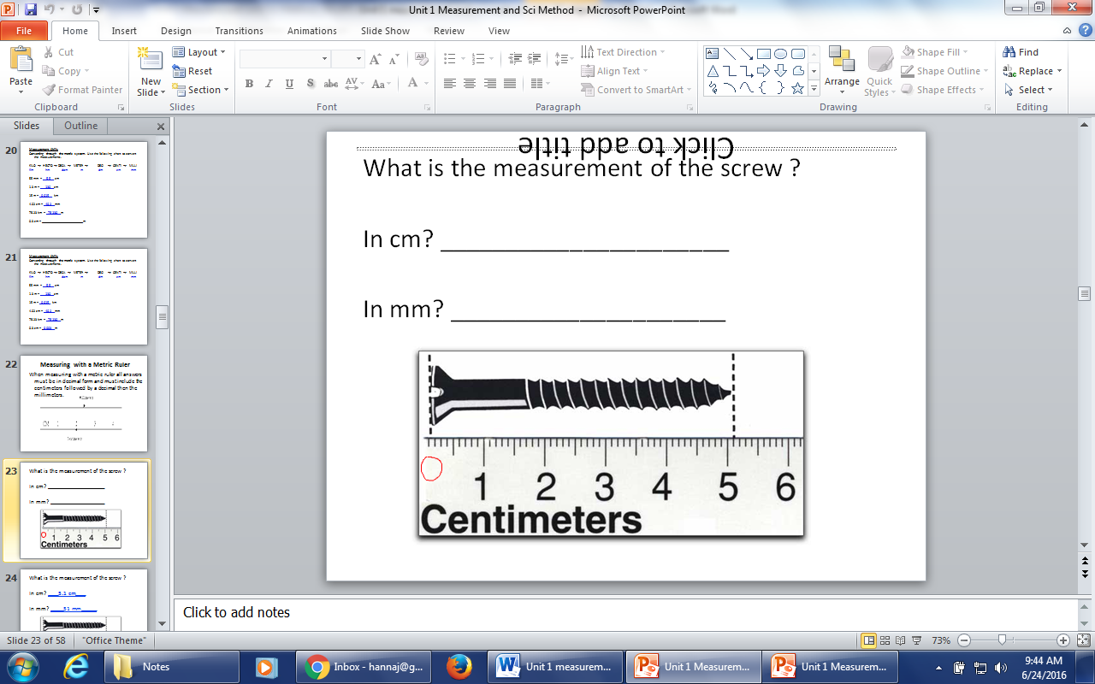

In cm? ______________________

In mm? _____________________

**Measuring area using a ruler**

Area =

Units of area =

Find the area of the block below:

Show work below

F = L X W

S =

A =

**Measuring volume with a graduated cylinder**

* Graduated cylinders come in many different ___________________: including 10 ml, 25 ml, 50 ml, 100 ml, 500 ml, and 1000 ml.
* Graduated cylinders are used to determine the volume of_____________________________.
* An interesting characteristic of liquids in glass containers is that they curve at the

edges due to ____________________ forces (like a straw). This curvature is called the***________________________***.

- With water in glass, the meniscus will ________________________at the edges and down in the center, just like the smile on this smiley face.



Curve up

Curve down



***When reading a graduated cylinder you want to:***

- measure the _____________________portion of the meniscus.

- be eye level with the __________________of the liquid

- read the ***_____________________________of the meniscus***

***-*** Units for liquid volume =

Try to determine the volume of the following containers

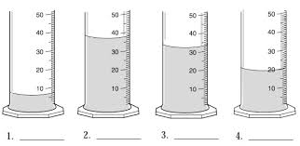

**[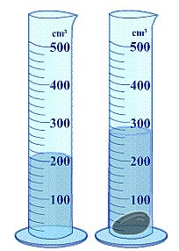](http://www.google.com/url?sa=i&rct=j&q=&esrc=s&frm=1&source=images&cd=&cad=rja&docid=cWYD-Zl9EBj6-M&tbnid=O63y3N33LbM4NM:&ved=0CAUQjRw&url=http://smithscience201.wikispaces.com/F-pipets+volume&ei=LAPSUZetAs3JrAfv9oGQCw&psig=AFQjCNHygLjVmtEy4Ibe2atp23fzCmMciA&ust=1372803329199367)**What is the volume of object?

Volume of the Liquid (A) = __________

Volume of the liquid and object (B) = ____________

(B) – (A) = volume of object

Volume of object = _______________

**Measuring volume for solid objects using a ruler**

Volume =

Units for volume =

Find the volume of the block below

4.2 cm

9.4 cm

3.6 cm

Show work below:

F = L x W x H

S=

A=

**Measuring Temperature**

* Temperature is the measure of how _________________ or ________________ something is
* The correct unit of temperature in the metric system is ______________________
* Thermometers are read ________________________ when temperatures are above zero
* Thermometers are read ________________________ when temperatures are below zero. They will also have a _______________________ sign in front of the temperature.

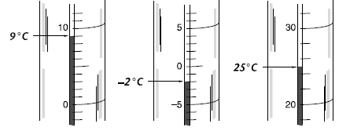Examples:

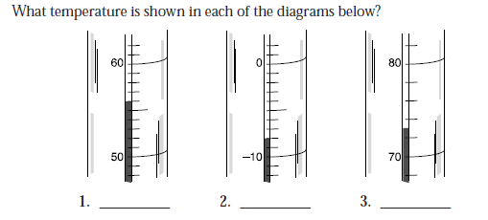

**4.** Suppose that at 9:00 A.M. the temperature of a room is 18°C, and at noon it is 24°C.What was the increase in temperature?

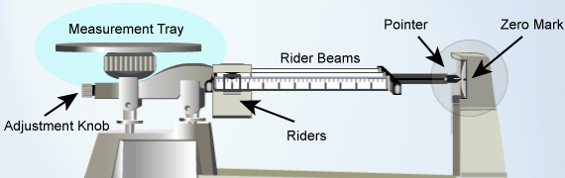**Measuring Mass**

* A unit of mass in the metric system is the _________________________
* Metric mass is measured in the science laboratory by the measuring device called a _______________________

The parts are all labeled in the picture to the right.

1) Check to see if the pointer is pointing to _____________________

- If the pointer is above the zero turn the knob _________________________ (down) you

- If the pointer is below the zero turn the knob _________________________ (up) from you

2) Put the object on the measuring tray to find the mass.

3) Find the mass by starting with the _________________ rider, then the _______________ riders and lastly move the __________________ rider.

[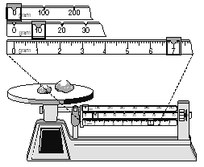](http://kootation.com/science-8-cumulative-chapters-1-4-matter-atoms-&-periodic-table/proprofs.com*quiz-school*upload*yuiupload*1101927013.jpg/)4) Finally add all the riders together to get the final mass

* The final mass to the right is ____________________
* The final mass below is ____________________

[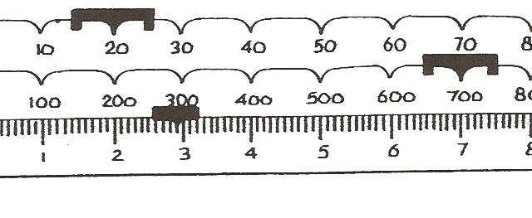](http://kootation.com/what-is-the-total-mass-on-this-triple-beam-balance/tksmith.iweb.bsu.edu*EDTEC660*images*mass_tbb_quiz.jpg/)

**Part 3 :Steps of the Scientific Method:**

***To remember the order***

***Paul***

***Ran***

***Happily***

***Exiting***

***Rachel’s***

***Car***

1.

2.

3.

4.

5.

6.

**SCIENTIFIC METHOD**

WHAT IS THE SCIENTIFIC METHOD?

1) Identify the Problem:

*Always in the form of a _______________________*

*Ex.*

2) Research the Problem:

*Gather ________________________*

Ex.

3) Forming a Hypothesis:

*Educated guess in form of _____________________*

Ex.

4) Setting up a Controlled Experiment:

Only 1 ___________________________ is tested

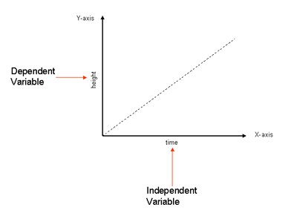

a. *Control group:*

Does not have a variable 🡪

Ex.

b. *Experimental group:*

*Group that has the _______________________________*

*to be tested*

*Ex.*

*c. Independent Variable: ( ____ decide)*

Goes on the __________

Ex. ___________________ studying for test

d. *Dependent Variable: ( _________)*

Goes on the ____________

Ex. ________ on the test

5. Recording and Analyzing **RESULTS**Put data in ______________________________________________ and analyze the results. See if it supports your hypothesis

Data can be separated into two categories

1. _______________________________: is descriptive information (it *describes* something)
2. _______________________________: is numerical information (numbers).

**Example: What do we know about Arrow the Dog?**

**________________________________________**:

- He is brown and black

- He has long hair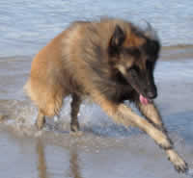

- He has lots of energy

**________________________________________**:

* + He has 4 legs
  + He has 2 brothers
  + He weighs 25.5 kg
  + He is 565 mm tall

6. Drawing a **CONCLUSION**

Explanation supported by _______________________; answer to the problem

Ex.