Name ___________________________________________ Date _______________
Science Ms. Hanna

Colors of the Rainbow Lab

Objectives  1. to measure chemicals with a graduated cylinder.  2. to use the metric system.  3. to follow directions.  4. to practice lab safety procedures. | Materials  - 3 beakers, each with a different color of  water (red, yellow and blue)  5 drops of color per 100 ml of water  - 6 test tubes, ~ 30 ml  - Test tube stand  - 100 ml and 10 ml graduated cylinders

Procedure: Part 1 :
- Label 6 test tubes in order: A, B, C, D, E & F. (If you are not able to label the test tubes, imagine that they have labels and are in the rack in order from A-F)
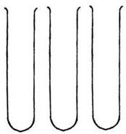

- Measure the following amounts of water and pour into the test tubes listed
Water Color | Amount | Test Tube
RED | 19 ml | A
YELLOW | 18 ml | C
BLUE | 18 ml | E
RED | 7 ml | F
BLUE | 4 ml | F

Procedure: Part 2:
Measure the following amounts of water from the ‘FROM’ test tubes, and pour them into the ‘TO’ test tubes:
Step | Amount | FROM Test Tube | TO Test Tube
1 | 4 ml | C | D
2 | 7 ml | E | D-swirl
3 | 8 ml | A | B
4 | 3 ml | C | B-swirl

7. SAVE your results (do not dump them out yet!). Measure the contents of each test tube and record how many mL were found in each test tube in table 1 (on back).
8. AFTER you have recorded all data (colored the test tubes and measured in the data section) empty the contents of each test tube and rinse with water.
9. Answer questions.

Data:
Draw what your 6 test tubes look like below. Make sure you use the correct color and draw the estimated level of liquid in each test tube.

Table 1: Test Tube results
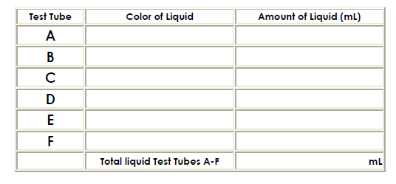
Results/Conclusions:
1) Are your tubes about the same volume? ___________________ (± 2 ml)

2) If not, please give some sources of error that might have occurred. (Be specific! – Think of things you could do differently if you conducted this lab again that might give you better results)
__________________________________________________________________________________________________________________________________________________________________

3) What instrument did you use in this activity to make measurements? __________________________

4) What unit of the metric system did you use? ________________________________

5) Why is it important to follow directions exactly?
__________________________________________________________________________________________________________________________________________________________________

6) Why is correctly measuring so important in a job like being a pharmacist? What could be some of the consequences (problems) of incorrectly measuring drugs and/or chemicals?
___________________________________________________________________________________________________________________________________________________________________________________________________________________________________________________

7) Look at your hands. Do you have any stains on your hands? How about your lab papers? Why might this be a problem if the colors were harmful chemicals rather than just food coloring?
__________________________________________________________________________________________________________________________________________________________________

