Name __________________________________
Ms. Hanna

Laboratory Safety and Equipment

1. When doing an activity, always _____________ the entire procedure (steps) BEFORE beginning the activity. Make sure you are aware of any special
_____________.

2. ALWAYS follow procedures _____________! DO NOT leave out any ________.
DO NOT ______ any steps.

3. Always clean up any spills _________________. DO NOT touch ___________
_______, tell the teacher immediately and she will properly dispose of the glass.

4. NEVER point any closed container that is being _________ toward anyone!

5. Always treat any HOT PLATE or container on a HOT PLATE as it if were _______.

6. Always ________ up sleeves, ______ back long hair, and ________ SAFETY GOGGLES during all science laboratory activities.

7. Always handle _______ ____________ with care. NEVER __________ them with your hands!

8. Always __________ up your work area after EVERY activity. Be sure to wash your hands before and after every experiment.

9. Always be sure to work in the ____________ of the table so chemicals, bunsen burners and glassware are not knocked off the table.

10. Always ____________ accidents, breakages and _____________ to your ______________ immediately!

27)

Part 1: Find each piece of equipment throughout the classroom. Record the letter for the equipment that you find around the classroom.

Letter | Name | Function
 | Beaker | Hold liquids
 | Erlenmeyer flask | Hold liquids
 | Test tube | Hold liquids
 | Test tube rack | Hold test tubes
 | Test tube brush | Clean test tube
 | Graduated cylinder | Measure liquid volume
 | Metric ruler | Measure length
 | Thermometer | Measure how hot or cold something is
 | Magnifying glass | Make objects appear larger
 | TBB | Measure mass of object
 | Compound microscope | Make microscopic specimens appear larger
 | Microscope slides | Hold microscopic specimens
 | Cover slips | Cover microscopic specimens
 | Medicine dropper | To release tiny amount of liquid at a time
 | Bunsen burner | Heat objects
 | Tongs | Hold hot glassware
 | Ring stand | Hold objects being heated over Bunsen burner
 | Fire blanket | Cut off oxygen supply to a fire in order to put one out. Located: ____________ _________________________________
 | Eye wash | Rinse eyes if burned by hot or acidic liquids. Located: __________________  ___________________________________
 | Emergency gas shut off | Turns off gas supply to entire classroom.  Located: ___________________________
 | Goggles | Protect eyes

Part 2: On the lines provided, name the piece of lab equipment you would use to perform the task described.
1. Measure length ________________________________________________
2. Measure temperature ___________________________________________
3. Observe a cell _________________________________________________
4. Pick up a beaker _______________________________________________
5. Protect your eyes ______________________________________________
6. Measure volume (liquid)__________________________________________
7. Hold liquid (3)_______________ __________________ ___________________
8. Heat a test tube _______________________________________________
9. Place water on a slide ___________________________________________
10. Wash out a test tube ___________________________________________

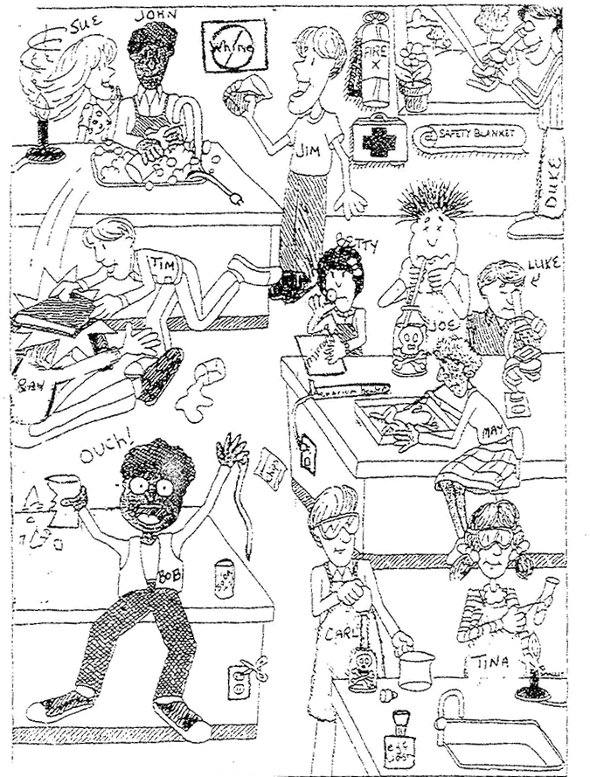
Part 3: View the picture
and answer the questions.

1. List 3 unsafe activities shown in the illustration and explain why each is unsafe.
a.
b.
c.

2. List 3 correct lab procedures depicted in the illustration.
a.
b.
c.
3. What should Bob do after the accident?
4. What should Sue have done to avoid an accident?

5. What are two other safety practices that need to be done when heating liquids in laboratory glassware?

6. What will happen to Tim and Ray for horse playing in the laboratory?

7. What is wrong with Joe’s technique? What should he have done to identify the unknown substance?
8. List three items in the illustration that are there for the safety of the students in the lab.
9. If Sue was holding a pressurized container, what should she not put it near and why?

10. If Bob’s beaker contained something that was caustic what could happen to him?

