Name ______________________________________________ Date _________________
Science Ms. Hanna
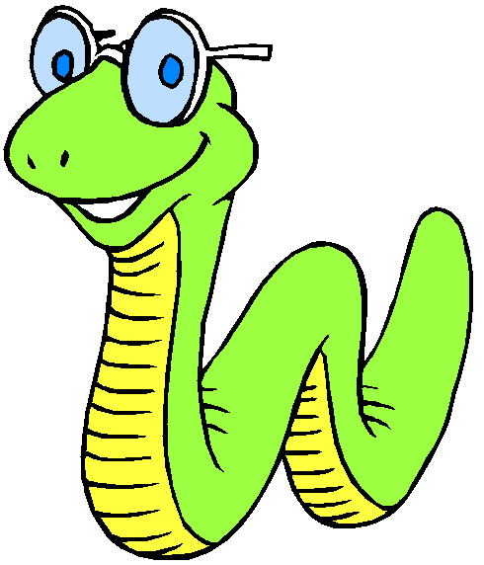

Setting Up the Scenario
Sam has been spending his summer boating on the great lakes. However, he’s not too bright (after all, the brains of worms are pretty small). He’s never learned how to swim, and he never wears his life preserver. The worst has happened! His boat has capsized and he’s stuck! Fortunately, his life preserver is in the boat, but unfortunately he does not know how to reach it without falling off and drowning.
To get to shore, Sam needs to retrieve a life jacket from underneath the boat so that he can float to shore. You and your partners' job is to save Sam by retrieving the life jacket from under the boat and putting it on Sam. Unfortunately, the only tools you can use to accomplish this task are paperclips (3). (1 per person, or you can give them 2 to one person and 1 to another person). You cannot touch Sam, the boat, or the life preserver with your bare hands.

Use the Scientific Method to:
Problem:
__________________________________________________________________________________________________
__________________________________________________________________________________________________
__________________________________________________________________________________________________

Hypothesis: (Remember that a hypothesis is an ‘if-then’ statement: if I do this, then this will happen)
__________________________________________________________________________________________________
__________________________________________________________________________________________________
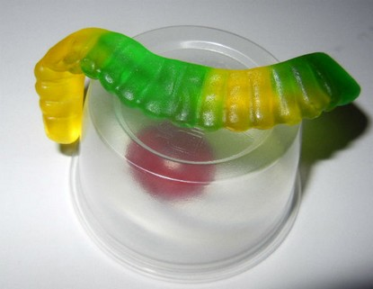
Materials:
- Gummy Worm (Sam)
- Gummy “Life Saver” preserver
- 1 Plastic Cup (overturned boat)
- 3 Paper Clips (only thing you can touch)

Procedures:
  - Work with your partner and "Save Sam".
  - Follow the rules. --> Sam, the boat, the life preserver can be touched only with the paper clips. NO HANDS.
  - In the ‘Data’ section on the back, draw and label the following:
- Diagrams (pictures) of how you saved Sam
- A detailed protocol describing what happened in the diagrams

Data:

Results/Conclusion:
1) Was your group successful? _________________ Did your plan (hypothesis) work? __________________
2) What worked? What didn't work?
______________________________________________________________________________________________________________________________________________________________________________________________________________________________________________________________________________________________________
3) Would it have been easier if you were working alone? Why or why not?
______________________________________________________________________________________________________________________________________________________________________________________________________________________________________________________________________________________________________
4) Was there a clear leader in your group? Did someone call the shots or make decisions about how to save Sam.
____________________________________________________________________________________________________________________________________________________________________________________________________
5) Could Sam be saved if you had only one paperclip?
____________________________________________________________________________________________________________________________________________________________________________________________________
6) Did you mangle poor Sam trying to make it work?
____________________________________________________________________________________________________________________________________________________________________________________________________

