Name _____________________________________________ Date __________________

Science Ms. Hanna

**SpongeBob and his Bikini Bottom pals have continued doing a little research to solve some problems. Read the description for each experiment and answer the questions.**

[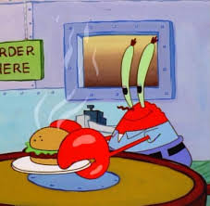](http://www.google.com/url?sa=i&rct=j&q=&esrc=s&frm=1&source=images&cd=&cad=rja&docid=iyt9S25pzw5WBM&tbnid=p_OYr5XeOg-RjM:&ved=0CAUQjRw&url=http://spongebob.wikia.com/wiki/Eugene_H._Krabs&ei=DGVNUvLoLJHO8wSRooGgCg&bvm=bv.53537100,d.aWc&psig=AFQjCNFck4rxDUIjAFBqeL2gUPJpSKDu3g&ust=1380890203952318)**Krusty Krabs Breath Mints**

*Mr. Krabs created a secret ingredient for a breath mint that he thinks will “cure” the bad breath people get from eating crabby patties at the Krusty Krab. He asked 100 customers with a history of bad breath to try his new breath mint. He had fifty customers (Group A) eat a breath mint after they finished eating a crabby patty. The other fifty (Group B) also received a breath mint after they finished the sandwich, however, it was just a regular breath mint and did not have the secret ingredient. Both groups were told that they were getting the breath mint that would cure their bad breath. Two hours after eating the crabby patties, thirty customers in Group A and ten customers in Group B reported having better breath than they normally had after eating crabby patties.*

1. Which people are in the control group? _____________________________________________________________

2. What is the independent variable? __________________________________________________________________

3. What is the dependent variable? __________________________________________________________________

4. What should Mr. Krabs’ conclusion be?

5. Why do you think 10 people in group B reported fresher breath?

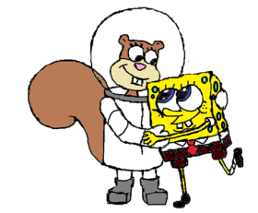**SpongeBob Clean Pants**

SpongeBob noticed that his favorite pants were not as clean as they used to be. His friend Sandy told him that he should try using Clean-O detergent, a new brand of laundry soap she found at Sail-Mart. SpongeBob made sure to wash one pair of pants in plain water and another pair in water with the Clean-O detergent. After washing both pairs of pants a total of three times, the pants washed in the Clean-O detergent did not appear to be any cleaner than the pants washed in plain water.

6. What was the problem SpongeBob wanted to investigate?

7. What is the independent variable? _________________________________________________________________

8. What is the dependent variable? ________________________________________________________________

9. What should Sponge Bob’s conclusion be?

**Super Bubbles**

Patrick and SpongeBob love to blow bubbles! Patrick found some Super Bubble Soap at Sail-Mart. The ads claim that Super Bubble Soap will produce bubbles that are twice as big as bubbles made with regular bubble soap. Patrick and SpongeBob made up two samples of bubble solution. One sample was made with 5 oz. of Super Bubble Soap and 5 oz. of water, while the other was made with the same amount of water and 5 oz. of regular bubble soap. Patrick and SpongeBob used their favorite bubble wands to blow 10 different bubbles and did their best to measure the diameter of each one. The results are shown in the chart

10. What did the Super Bubble ads claim?

11. What is the independent variable? __________________________________________________________________

12. What is the dependent variable? ___________________________________________________________________

13. Look at the results in the chart.

[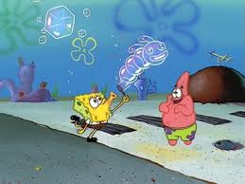](http://www.google.com/url?sa=i&rct=j&q=&esrc=s&frm=1&source=images&cd=&cad=rja&docid=tTDC7K1lIJX7LM&tbnid=3oKIshjtPgtx1M:&ved=0CAUQjRw&url=http://gumshoeblog.org/gumshoe-home/2013/6/19/the-spongebob-bubble&ei=sGdNUofMBI7u8AS82YH4CQ&bvm=bv.53537100,d.aWc&psig=AFQjCNElvHwIaIzvMHphh9KVgOdG_4XyMg&ust=1380890906965747)

1. Calculate the average diameter for each bubble solution.

Super Bubble = _______________ cm Regular Soap = _________________ cm

1. What should their conclusion be?

14. Are the results reliable? Why or why not?