Name __________________________________________________ Date _____________________
Science Ms. Hanna

Part 1: Match the correct word with the definition provided

______ 1) To group items on how they are alike A. Conclusion
______ 2) To suggest an answer to a problem B. Record and organize
______ 3) To give a logical result to a problem C. Classify
______4) To use your 5 senses to gather information D. Inference
______5) To take down observations (data) and arrange them into a chart or a graph E. Hypothesize
______6) A guess about the future based on the past F. Measure
______7) To make a careful guess G. Predict
______8) To give a possible explanation for an observation H. Estimate
______9) To find the exact amount of something I. Observation

Part 2: Observation or Inference
Directions: Determine whether the statement is and inference or an observation based on the picture given. Write I for inference or O for observation.
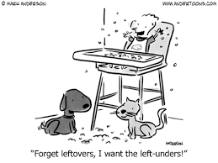
______ 10) There are 2 pets in the picture
______ 11) The cat likes table food
______ 12) The dog is hungry
______13) The baby is throwing food
______ 14) The dog is going to eat all of the food
______15) The cat is light in color

Part 3: Short Answer
16) What are your 5 senses?
A) ______________________________ B) ______________________________
C) ______________________________ D) ______________________________
E) ______________________________

